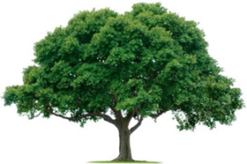
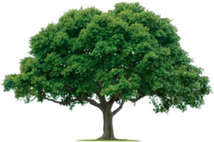
OAKRIDGE NEIGHBORHOOD ASSOCIATION
Monthly Board Meeting
Monday, November 1, 2021, at 7:00 P.M.
Zoom Meeting

Board Meeting Minutes

- CALL TO ORDER: Sharon Parrish, Secretary
    - The September 23, 2021, general meeting minutes and the October 4, 2021, zoom meeting minutes were reviewed. The minutes were motioned for approval by David Parrish, seconded by Scott Barnes, and approved unanimously.
- UPDATES:
- ENVIRONMENTAL: Overview leak was repaired quickly. The sign at Richland was finally installed by the homeowner. Krystine Ma, who expressed interest in landscaping the Ridge Oak medians, seems unavailable.
- CRIME WATCH: Our NPO Tommy Barnes has a rare form of cancer and is seeking treatment at M.D. Anderson in Houston. The Garland Police Never Walk Alone Foundation is assisting with his expenses. The ONA Board decided that all Holiday donations would go to the Foundation to support Officer Barnes.
- MEMBERSHIP: Membership: As of November 1, there were 357 new members of ONA.
- EVENTS: November 7 will be the Good Sam’s Food and Sock Drive. ONA will do cookies rather than ice cream. The October 15 Walk Around event was a success. As was the ONA National Night Out.
- TREASURY: For monthly financials see attached.
- COMMUNICATION: No report.
- The meeting was ADJOURNED at 8:16 PM.
- NEXT BOARD MEETING
Date: Monday, January 3, 2022
Time: 7:00 PM
Location: Zoom
- NEXT GENERAL MEMBERSHIP MEETING
Date: Thursday, February 24, 2022
Time: 7:00 PM via Zoom
Location: Zoom

