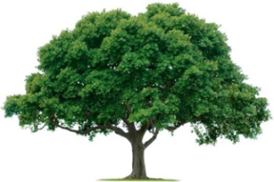
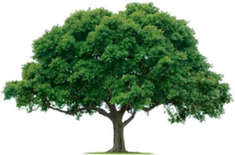
OAKRIDGE NEIGHBORHOOD ASSOCIATION
Monthly Board Meeting
Monday, January 3, 2022, at 7:00 P.M.
Zoom Meeting

Board Meeting Minutes

- CALL TO ORDER: Sharon Parrish, Secretary
The November1, 2021 Meeting Minutes were reviewed and approved. Scott Barnes motioned, and David Parrish seconded. All approved unanimously.

- UPDATES: Scott will see who is interested to serve on the nominating committee. Districts two, four and six are open for the next two-year time period. Melanie Busby noted that some storm drains are nasty and have been reported to Code Compliance.

- ENVIRONMENTAL: David Parrish reported that all beds and flags were in good shape. David will talk to PlatinumScapes about options for using the $500 for Ridge Oak medians.

- EVENTS: Jackie Reynolds asked about some events the coming year. The Spring Fling was tentatively scheduled for May 15, 1-4 pm. Cecile Labossiere would also like to have some Membership events as well.

- MEMBERSHIP: There are 360 members to date. 261 for events and 8000 donations for Tommy Barnes. Tommy and his family really appreciate ONA’s support.

- TREASURY: Keith Engler noted that ONA collected $7,332.50 for Officer Barnes. He rounded that number up to or $8,000 anticipating additional payments coming in late. He wrote the check for $8,000. Unfortunately, no additional checks came in, so the ONA paid $667.50 over what was collected. Scott motioned to approve the $667.50 and Melanie Busby seconded. The motion was approved. Keith anticipates ONA will have $2,209.14 remaining at the end of this fiscal year. We still have $500 budgeted for the Ridge Oak entrance and $561 for Special Events.

- Due to the changes in the Garland Bulk Procedures, hopefully we will be using the Richardson Post Office Procedures.

- CRIME PREVENTION AND SAFETY: Several residents in Oakridge heard gun shots over the Holidays in the neighborhood across Buckingham Rd. A short blurb should be published in the next month or two on this situation.

- The meeting was ADJOURNED at 8:15 PM.

- NEXT BOARD MEETING
Date: Monday, January 3, 2022
Time: 7:00 PM
Location: Zoom

- NEXT GENERAL MEMBERSHIP MEETING
Date: Thursday, February 24, 2022
Time: 7:00 PM via Zoom
Location: Zoom

