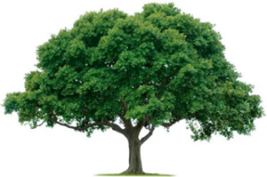
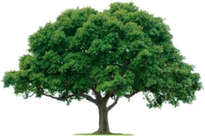
OAKRIDGE NEIGHBORHOOD ASSOCIATION
Monthly Board Meeting
Monday, February 7, 2022, at 7:00 P.M.
Zoom Meeting

Board Meeting Minutes

- CALL TO ORDER: Sharon Parrish presented the January 3 Board Meeting Minutes for review and approval. Scott Barnes motioned, and David Parrish seconded. All approved unanimously.
- Vicki Litton, Veronica Corbin, and Dan Nickols volunteered to be members of the Nominating Committee. This was motioned and passed.
- An additional check was donated for Tommy Barnes totaling approximately $9,000.
- Environmental: requested sprinkler check and an evaluation of the current flowers (pansies) from the ONA landscaper, before discussing Spring plantings and Ridge Oak median plantings.
- Events: City Party Trailer is available on May 15 for the Spring Fling. Anticipating 150 attendees. More details to follow. Other event ideas- Pet parade? Book exchanges or plant swap? Happy hour, maybe 25 people?
- Membership: Current membership is 361 homes. Cecile would like Pop-ups two times per week in April and May.
- Treasury: Keith reported we were in good shape financially. He will send a report later this week.
- Communication: newsletter out by the February 20th. Newsletter will be six pages for April and May to cover Membership Drive.
- Crime & Safety: Oakridge had the lowest crime rate ever.
- The meeting was ADJOURNED at 8:07 PM.
- NEXT BOARD MEETING
Date: Monday, March 7, 2022
Time: 7:00 PM
Location: Zoom

- NEXT GENERAL MEMBERSHIP MEETING
Date: Thursday, February 24, 2022
Time: 7:00 PM via Zoom
Location: Zoom

