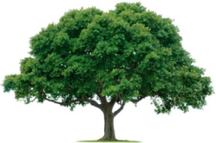
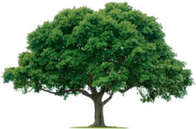
OAKRIDGE NEIGHBORHOOD ASSOCTATION
GENERAL MEETING USING ZOOM
September 23, 2021

- CALL TO ORDER: Michelle Mizerak opened the general meeting at 7:05 PM. Attendance was 23 members, quorum met. See attached,
- Officer Barnes opened thanking the neighborhood for its support. He also had several items to discuss namely: video crime watch and new signage, doorbell usage, rapidity of crime identification and the Lock Box Program. Officer Barnes said there our contact are information for many of these programs and the purchase of a key. See attached slides. Officer Barnes installs materials himself in discrete locations. Officer Barnes installs materials himself in discrete locations. See attached slides.
- Theft of catalytic converters is a new issue. These metals can be removed in a matter of seconds. Most thefts are from unlocked vehicles. You should remove valuables, especially your guns and keys.
- The National Neighborhood Night Out is Tuesday, October 5, 2021, from 6-7pm at the Duck Creek Golf Club Parking Lot. The Police Chief really likes these events.
- Dylan Hedrick, our City Councilperson, reported that due to financial improvements staff raises were increased. Work was initiated on the Garland Square. A study is being done on traffic safety signs and lights. He updated us on the status of several Bond projects including splash pads, Holford and Rick Oden Parks.
- Christine Beyers says Daytimers has been an organization since 1998. There have had 34 to 17 members. Their current focus is on recipes but, they enjoy educational programs and fellowship.
- The General Meeting minutes from the May 25, 2021, were reviewed. These minutes were motioned for approval by David Parrish, seconded by Scott Barnes, and approved unanimously.
- Treasurer Keith Engler provided a financial update. See attached.
- Jackie Reynolds provided the following events: Walk & Greet with Ice Cream, Friday, October 15th, 6:30 p.m. and a Good Sams Food & Sock Drive, Sunday, November 7th, 2-4 p.m.
- Cecile Labossiere reported that 351 members to date. See attached.
- Michelle Mizerak provided the Communications update. See attached.
- David Parrish provided the Environmental update. See attached.

- The next General Meeting will be February 24, 2022.

- ADJOURN: The meeting adjourned at 8:15 PM. (Scott Barnes motioned. David Parrish second. All approved.)

