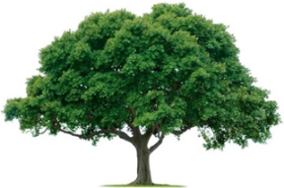
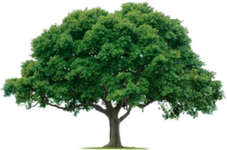
OAKRIDGE NEIGHBORHOOD ASSOCTATION
GENERAL MEETING USING ZOOM
February 24, 2022

- CALL TO ORDER: Scott Barnes called the General Meeting to order at 7:05 PM. Attendance was ?? members, quorum met?. See attached ?.

- Garland Police Department is hosting May, June, and July Open Houses. Dave Wange had Covid, status unknown.

- Dylan Hedrick- February 11 was Build Garland Ribbon Cutting on four facilities: Fields Recreation Center, Transportation Operation Center is most up to date, and Animal Adoption Center, which has separate feline and dog corridors. Police Evidence area is being totally revamped. Downton Square Fund-Raising Bricks presents a big sponsorship opportunity.

- The General Meeting minutes from the September 23, 2021Meeting were reviewed and approved unanimously.

- The Nominating Committee of Vickie Litton, Veronica Brown-Corbin, and Dan Nichols was approved.
- Treasurer Keith Engler provided a financial update. See attached.
- Events- Jackie Reynolds discussed the Spring Fling event and the need to acquire 2 extra grills. These are usually provided by Board Members or willing neighbors.
- Membership- Cecile Labossiere reported did well in renewing Members. 47 Welcome Bags are needed. See attached.
- Communications- Heather Englebretson reported February newsletter was lost, just go to the website. provided the Communications update. See attached.
- David Parrish provided the Environmental update. See attached.
- Keep reaching out to support Officer Barnes.

- Crime Watch- Joan Nichols reported on the low Oakridge Crim rate. They are seeing some issues with unlocked cars, porch pirates, and catalytic converter thefts.

- The next General Meeting will be May 26, 2022.

- ADJOURN: The meeting adjourned at 8:15 PM. (Scott Barnes motioned. David Parrish second. All approved.)

