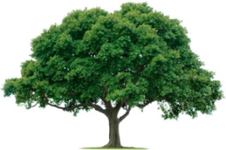
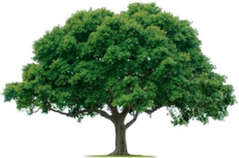
OAKRIDGE NEIGHBORHOOD ASSOCIATION
Monthly Board Meeting
Tuesday, June 7, 2022, at 7:00 P.M.
Zoom Meeting

Board Meeting Minutes

- CALL TO ORDER: Approval of the May 2 Board Meeting Minutes was motioned by Joan Nichols and second by Cecile Labossiere. The motioned was approved.
- Non-Committee Discussions: Billy Ray Thomas said he thought our priorities should be those things that were most visible, such as, the entrances and the holiday decorations. David Parrish reviewed the known problems with the five sprinkler systems. Some seasonal flowers seem dry. David asked that Board Members alert him when they see issues. Many membership funds go directly to the beautification fund. David is working with the landscaper and volunteers to address issues.
- The Board then discussed the aging holiday decorations become need to be evaluated and replaced periodically. The Board discussed the need for a Decorating Committee.
- Environmental: David indicated the topic had been covered, thoroughly.
- Events: Jackie Reynolds said only two homes had expressed interest in a neighborhood garage sale. Heather Englebretson will provide some marketing with a cut-off of June 15. The Board discussed hosting social (happy) hours at the golf club and more events when the weather gets cooler.
- Membership- Cecile Labossiere reported Membership is 18% down from this time next year. Board members should encourage neighbors to join. There are more Pop-ups events and perhaps social (happy) hours that can help with Membership.
- Treasurer- Veronica Corbin has access to the Chase accounts, but Keith Engler’s direct payment links were lost. Veronica working with Keith to setup her QuickBooks account and create ONA financial reports.
- Communications- Heather Englebretson reminded the Board the digital newsletter distribution will kick off in June. Only one resident requested a hard copy newsletter. Hard copy newsletters will be distributed to all 1,166 households in September, December, and May. Heather is stepping down effective August 1. ONA needs a new Communication Director. Ruba Qewar can assist with graphic design and WordPress tasks.
- Crime & Safety- Joan Nichols reported crime is still down in Oakridge. There was a hit and run on Jupiter near Ridge Oak by a man in socks.
- Regular Board Meeting Day: First Monday generally does not work for Billy Ray Thomas, ONA President. After discussion the Board decided to move the regular monthly meeting day to the second Monday of the month. There is no Board meeting in August.
- The meeting was ADJOURNED at 8:19 PM.
- NEXT BOARD MEETING
Date: Monday, July 11, 2022
Time: 7:00 PM
Location: Zoom

- NEXT GENERAL MEMBERSHIP MEETING
Date: Thursday, September 22, 2022
Time: 7:00 PM
Location: To be determined.

