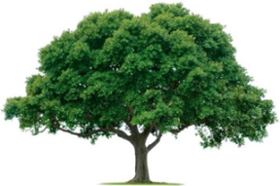
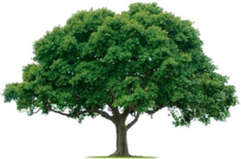
OAKRIDGE NEIGHBORHOOD ASSOCIATION
Monthly Board Meeting
Tuesday, July 11, 2022, at 7:00 P.M.
Zoom Meeting

Board Meeting Minutes

- CALL TO ORDER: 7:05 PM. Approval of the June 7 Board Meeting Minutes were motioned, seconded, and approved.
- Non-Committee Discussions: Board discussed landscaping and holiday decorations. There was a consensus for a Holiday Decorations Committee to acquire something eye catching for each of the nine entrances. People are needed to lead the Committee. Someone’s neighbor agreed to make ribbons.
- Environmental: Landscaping challenges are ongoing.
- Events: Jackie Reynolds reported Oakridge Garage Sale was a success. Oakridge Happy Hour will precede the September 22 General Meeting at the Duck Creek Golf Club. Jackie is working with Good Sam’s on a food drive in the Fall.
- Membership- Cecile Labossiere reported Membership is down from this time next year. Report attached.
- Treasurer- Veronica Corbin is working to get up to speed on QuickBooks.
- Communications- Heather Englebretson reported first the digital newsletter distributed in June. Board is looking for a person to replace Heather.
- Crime & Safety- Neighbors Night Out is Tuesday, October 4. Safety Committee is working on the details.
- The meeting was ADJOURNED at 8:40 PM.
- NEXT BOARD MEETING
Date: Tuesday, September 12, 2022
Time: 7:00 PM
Location: Zoom

- NEXT GENERAL MEMBERSHIP MEETING
Date: Thursday, September 22, 2022
Time: 7:00 PM
Location: To be determined.

