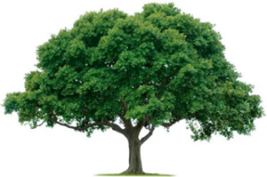
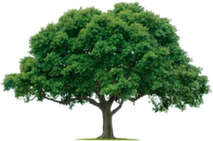
OAKRIDGE NEIGHBORHOOD ASSOCIATION
Monthly Board Meeting
Tuesday, September 13, 2022, at 7:00 P.M.
Zoom Meeting

Board Meeting Minutes

- CALL TO ORDER: 7:05 PM. Approval of the July 11 Board Meeting Minutes were motioned by David Parrish, seconded by Melanie Busby, and all approved.
- Treasurer’s report is up to date and on budget. Several figures were marked for logistics and mailings.
- Membership reports 288 members vs 361 last year. Cecile sent list of non-renewing homes to the District Directors. A few more checks came in after that.
- Jill and Joan discussed the September, February, and May Newsletters. Several people want hard copies.
- National Night Out- Tuesday, October 4, 2022. Call for volunteers by Nextdoor and MailChimp for mail accuracy. Fire Department, Police Department/Ofc. Barnes, Councilman Dylan Hedrick, Mayor LeMay, and Pets. Potluck appetizers and the Golf Club Beverage cart. Bring your own chairs. Advertise by Nextdoor, MailChimp, and Newsletter.
- General Meeting, Sept. 29, 2022, 7:00 PM- Councilman Dylan Hedrick, Ofc. Barnes, maybe at the Golf Club. Preceded by Meet and Greet. All at Duck Creek Golf Club.
- Discussed Good Sam’s Food Drive led by high school service clubs.
- Environmental: Fall/Winter seasonal color planted after mid-October when pansies become available. We have regular sprinkler issues, due to our aging system. David will schedule a meeting with the contractor and some Board members to discuss options.
- Communications- Jill or Ruba to help with the Newsletter. Joan or Cecile will do research on mail assistance using UPS or FedEx services.
- The meeting was ADJOURNED at 8:52 PM.
- NEXT BOARD MEETING
Date: Tuesday, October 11, 2022, 7:00 PM via Zoom

- NEXT GENERAL MEMBERSHIP MEETING
Date: Thursday, September 29, 2022, 7:00 PM at Golf Club

