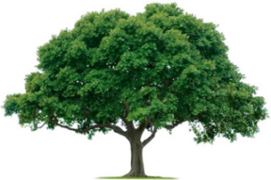
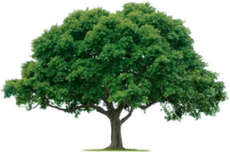
OAKRIDGE NEIGHBORHOOD ASSOCIATION
Monthly Board Meeting
Tuesday, October 11, 2022, at 7:00 P.M.
Zoom Meeting

Board Meeting Minutes

- CALL TO ORDER: 7:05 PM. The September 13 Board Meeting Minutes were motioned by Joan and seconded by Oliver; motion carried. The September 29 General Meeting Minutes were motioned by Joan and seconded by David; motion carried.
- Treasurer’s Report: Veronica provided ONA financial update. Three checks received this month.
- Neighborhood Night Out: an estimated 85 attendees. Guests included Councilman Dylan Hedrick, GPD, GFD, Neighborhood Vitality, Pink Coffee, a drone, and a motorcycle. Jack Catalona, our new tech guy, took pictures.
- Membership Report: Cecile provided a Membership update.
- Communications Report: Cheryl, Jill, and Joan are working on the November Newsletter. Input is due by October 15 to communications@oakridgena.org. Joan reported $495 is needed for newsletter software. Sir Speedy will provide bulk mail services for $110. Jacke motioned for ONA to cover both expenses and David seconded; the motion carried.
- Neighborhood Vitality: At November Neighborhood Summit Garland will recognized Newsletter of the Year and Neighborhood of the Year. Board discussed possibly applying for Neighborhood Vitality grant to update/replace all five sprinkler systems and/or brick work. David will seek estimate on sprinklers.
- Environmental: David provided a update. He still needs to schedule a meeting with the contractor and some Board members to discuss options.
- Survey: Board discussed need for a survey of the reasons that 80 households that did not rejoined this year.
- The meeting was ADJOURNED at 8:15 PM.
- NEXT BOARD MEETING
Date: Tuesday, November 15, 2022, 7:00 PM via Zoom

- NEXT GENERAL MEMBERSHIP MEETING
Date: Thursday, February 23, 2023, 7:00 PM at Golf Club

