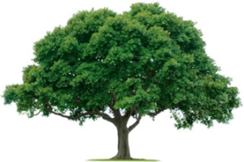
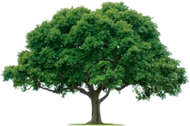
OAKRIDGE NEIGHBORHOOD ASSOCTATION
GENERAL MEETING USING ZOOM
May 26, 2022

- CALL TO ORDER: Scott Barnes opened the general meeting at 7:00 PM. Attendance was 24 members (i.e., Zoom participants), quorum met. See attached list of Attendees and the Meeting Slide Deck.

- Officer Barnes thanked everyone for our continued support. He is on desk duty. Looking at a multi-city task force for catalytic converter thefts. Thefts focused on Japanese cars, Fords, Jeep Wrangler, and other brands.

- Dylan Hedrick, our City Councilperson, spoke about several programs and recent Council elections. Districts 1 and 4 were unopposed. There is a runoff election in District 5. The Bond discussion focus on Parks and the new Animal Shelter. Many Oakridge streets are being repairs. There are a wide selection of music programs and movies being offered to the residents this summer. Several new businesses are going in along Jupiter. And Shiloh. Keith raised the concept of crosswalks which was a not viable due to low pedestrian traffic. New speed bumps are off set to allow better movement by fire department trucks.

- The General Meeting minutes from the February 24, 2022, were reviewed. These minutes were motioned for approval by Scott Barnes, seconded by David Parrish, and approved unanimously.

- Nominating Committee: Scott Barnes thanked the members of the Nominating Committee for their hard work. Scott Barnes motioned and Michelle Mizerak second the proposed nominees for approval. The motion carried unanimously.

- Treasurer: Keith Engler reviewed the Budget numbers and reported we were in good shape. See attached. Billy Ray Thomas motioned the Budget be approved, Scott Barnes seconded, and the Budget was approved unanimously. Members thanked Keith for all his hard work.

- Safety: We are keeping the Caring Bridge for Officer Barnes updated. Oakridge has had seven incidents this year to date.

- Communications: The digital newsletter distribution every month starts in June. Only one person has requested a hard copy of the Newsletter. Heather Englebretson indicated she was stepping down this Summer. There still will be hard copy newsletters in May, September, and December. Looking for volunteers as subs.

- Membership: We are a little behind in Membership this year according to Cecile Labossiere. She reported Memberships numbers for the last four years as a comparison. See attached.

- Events: Neighborhood Wide Garage Sale is on Saturday, June 25, 9 AM to 4 PM, cash only, no checks. Scott Barnes said the Spring Fling went great. Everyone enjoyed themselves. We all look forward to doing it again.

- David Parrish provided the Environmental update. See attached.

- The next General Meeting will be September 22, 2022.

- ADJOURN: The meeting adjourned at 8:10 PM. (Scott Barnes motioned. David Parrish second. All approved.

